Be Well
Chiropractic & Health
255 Hope Street Providence RI 02906
Patient Intake

Name Date ___________________________________

Address __________________________________________________________________________________________________

City State Zip ___________________________________

Phone Email Address ________________________________________________
Age Date of Birth Social Security # ______________________________________________

Gender _________________________________Preferred Pronoun ________________________Marital Status (S) (M) (D) (W)

Number of Children _______Occupation ____________________________Referred by _________________________________

Emergency Contact Phone Number _________________________________________

General Practitioner’s name & number _________________________________________________________________________

Please state the main reason for your visit._______________________________________________________________________

_________________________________________________________________________________________________________
Please list any difficulties you are experiencing with activities you have engaged in since your condition arose:
_________________________________________________________________________________________________________
Please check the statement that best applies to your expectations of care:
_____ I wish to improve my overall health and wellbeing. Other: ______________________________________________
_____ I am interested in structural/postural correction.
_____ I am interested in pain relief only. ______________________________________________

Please list all known allergies. ________________________________________________________________________________

Please list any medication, over the counter products, vitamins or herbs you are taking.
_________________________________________________________________________________________________________
Please list any previous dislocations or fractures (broken bones) and the year in which they occurred.
_________________________________________________________________________________________________________
Please list any previous surgeries or operations and the year in which they occurred.
_________________________________________________________________________________________________________
Please list any health conditions for which you have been seen by a physician in the past year.
_________________________________________________________________________________________________________
Have you ever had cancer? Y or N If Yes, What kind? __________________________________________________________ Please list any medical conditions not listed above. _______________________________________________________________

Family History
Do you have a family history of any of the following? Please indicate who has had this condition.

( ) High Blood Pressure ( ) Heart Attack ( ) Stroke
( ) Kidney Disease ( ) Emphysema ( ) Seizure-Convulsions
( ) Rheumatoid Arthritis ( ) Mental Illness ( ) Asthma
( ) Thyroid Disease ( ) Diabetes ( ) Cardiovascular
( ) Ulcer or Stomach Problems ( ) Cancer. what type?
( ) Other ____________________________________
Habits: (please check)
Cigarettes? Quantity ___________For How Long?
Alcohol? Quantity ____________For How Long?
Coffee? _______ Quantity ____________
Have you lost or gained weight in the past year? _________________________________________________________________
Do you exercise regularly? Y or N What kind of exercise? _______________________________________________________
Do you have a pacemaker or any metal implants? _________________________________________________________________
Females: Date of last menstrual period Do you have any reason to believe that you may be pregnant? Y or N

Is there anything else you would like to discuss with the doctor? _____________________________________________________
_________________________________________________________________________________________________________

Show Area(s) of Pain or Unusual Feeling
Mark the areas on this body where you feel the described sensations. Use the appropriate symbols. Mark areas of radiating pain. Include all affected areas.

Numbness Pins & Needles Burning Achy Stabbing
- - - - - 00000 xxxxx ***** / / / / /
Pain Chart | Neck-Shoulder-Arm-Pain  On a scale of zero to 10, I rate my discomfort as follows:  (___________________)  0 10  no pain severe pain  Mid Back Pain  On a scale of zero to 10, I rate my discomfort as follows:  (___________________)  0 10  no pain severe pain  Low Back and Leg Pain  On a scale of zero to 10, I rate my discomfort as follows:  (___________________)  0 10  no pain severe pain
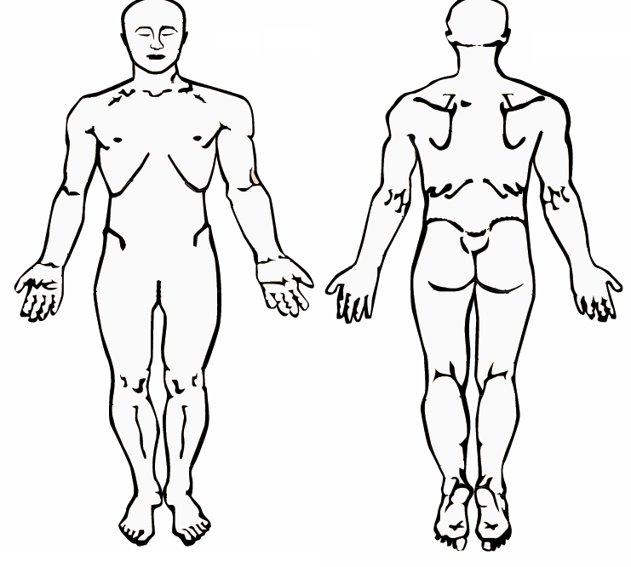

Have you had or do you now have any of the following symptoms which are or have been of significant distress to you? Please check under the letter N if you have these conditions now (within the past 12 months) or under P if you ever had these conditions in the past.
Now Past Now Past Now Past

N P N P N P

Appetite Decrease ___ ___ Fever ___ ___ Memory Loss ___ ___
Arm Pain ___ ___ Frequent Colds ___ ___ Menstrual Problems ___ ___
Arthritis ___ ___ Headache ___ ___ Muscle Spasms ___ ___
Back Pain ___ ___ Heartburn ___ ___ Neck Pain ___ ___
Balance Problems ___ ___ Vomiting Blood ___ ___ Nervousness ___ ___
Belching ___ ___ Blood in Stools ___ ___ Night Sweats ___ ___
Bowel Habit Change ___ ___ Blood in Urine ___ ___ Shoulder Pain ___ ___
Chest Pains ___ ___ Spitting Up Blood ___ ___ Sinus Problems ___ ___
Cold Feet ___ ___ Hemorrhoids ___ ___ Sleep Problems ___ ___
Cold Hands ___ ___ Hoarseness ___ ___ Stiffness ___ ___
Constipation ___ ___ Irritability ___ ___ Stomach Problems ___ ___
Depression ___ ___ Joint Swelling ___ ___ Fainting ___ ___
Diabetes ___ ___ Knee Pain ___ ___ Tension ___ ___
Diarrhea ___ ___ Leg Cramps ___ ___ Ears Ringing ___ ___
Double Vision ___ ___ Light Sensitivity ___ ___ Urinary Difficulty ___ ___
Dizziness ___ ___ Loss of Smell ___ ___ Urinary Incontinence ___ ___
Shortness of Breath ___ ___ Loss of Taste ___ ___ Urinary Retention ___ ___
Hypertension ___ ___ Dark Tarry Stools ___ ___ Vertigo ___ ___
Fatigue ___ ___
Other Symptoms:

Acceptance as a Patient
I understand and agree that the doctors of Be Well have the right to refuse to accept me as a patient at any time before treatment begins. The taking of a history and the conducting of a physical examination are not considered treatment, but are part of the process of information gathering so that the doctor can determine whether to accept me as a patient. When I am accepted as a patient, I assign full benefits to Be Well. I understand that Be Well reserves the right to charge me in the amount of $45.00 for any missed appointments without 24 hours notice.

Signature Date

Release of Records
I hereby authorize you, your employees and agents to furnish to all pertinent healthcare provider/person(s) and health insurance companies, all records and reports, including X-rays and photostatic copies, abstracts or excerpts of all records and any other information he/she/they may request relating to any examination, treatment or opinion concerning any condition that I or my dependent may have had in the past, now have, or may have in the future.

Signature Date

***For office use only***

H: __________ W:_________lbs BP: _______/_______ P:________bpm R: _________bpm

CC:
Patient Name:

• The nature of the chiropractic adjustment. The doctor may use her hands or a mechanical device upon your body in such a way as to move your joints. That may cause an audible “pop” or “click,” which signifies gases moving through those joints allowing for the movement to occur. You may feel or sense movement.
• The material risks inherent in chiropractic adjustment. As with any health care procedure, there are certain complications which may arise during a chiropractic adjustment. Those complications include: fractures, disc injuries, dislocations, and muscle strain, Horner’s syndrome, diaphragmatic paralysis, cervical myelopathy and costovertebral strains and separations. Some types of manipulation of the neck have been associated with injuries to the arteries in the neck leading to or contributing to serious complications including stroke. Some patients will feel some stiffness and soreness following the first few days of treatment.
• The probability of those risks occurring. Fractures are rare occurrences and generally result from some underlying weakness of the bone which we check for during the taking of your history and during examination and X-ray. Stroke has been the subject of tremendous disagreement within and without the profession with prominent authority stating that there is at most a one-in-a-million chance of such an outcome. Since even that risk should be avoided if possible, we employ tests in our examination which are designed to identify if you may be susceptible to that kind of injury. The other complications are also generally described as “rare.”1 Haldeman, Scott, D.C. M.D.
• Ancillary treatment. The doctor may offer treatment options, aside from chiropractic manipulation, that may include physiotherapy, rehabilitation, and nutritional and lifestyle counseling. Such further treatment options will be discussed with you after a thorough examination and report of findings has been completed.
• Other treatment options exist for your condition. The material risks inherent in such options and the probability of such risks occurring include:
• Overuse of over-the-counter medications produces undesirable side-effects. If complete rest is impractical, premature return to work and household chores may aggravate the condition and extend the recovery time. The probability of such complications arising is dependent upon the patient’s general health, severity of the patient’s discomfort, pain tolerance and self-discipline in not abusing the medicine. Professional literature describes highly undesirable effects from long term use of over-the-counter medicines.
• Prescription muscle relaxants and pain-killers can produce undesirable side effects and patient dependence. The risk of such complications arising is dependent upon the patient’s general health, severity of the patient’s discomfort, pain tolerance, self-discipline in not abusing the medicine and proper professional supervision.
• Hospitalization in conjunction with other care bears the additional risk of exposure to communicable disease, iatrogenic (doctor induced) mishap and expense. The probability if iatrogenic mishap is remote, expense is certain, exposure to communicable disease is likely with adverse result from such exposure dependent upon variables.
• The risks inherent in surgery include adverse reaction to anesthesia, iatrogenic (doctor caused) mishap, all those of hospitalization and an extended convalescent period. The probability of those risks occurring varies with many factors.
• The risks and dangers attendant to remaining untreated. Remaining untreated allows the formation of adhesions and reduces mobility which sets up a pain reaction further reducing mobility. Over time this process may complicate treatment making it more difficult and less effective the longer it is postponed. The probability that non-treatment will complicate a later rehabilitation is very high.
Regarding INSURANCE: This office will process your insurance forms upon request. We will do our utmost to provide sufficient information to your carrier to obtain payment for your treatment. We have found that, in some instances, insurance companies will deny or reduce payment despite our best efforts to demonstrate the necessity for care. In the event that full payment is not made for any reason, you must understand that you are responsible to make payment in full.

***Do Not Sign Until You Have Read And Understand The Above.***

I have read the above explanation of the chiropractic adjustment and related treatment. Treatment options, risks, and benefits have been discussed, and I have had my questions answered to my satisfaction. By signing below I state that I have weighed the risks and benefits involved in undergoing treatment and have decided to undergo the treatment recommended. Having been informed of all risks and benefits, I hereby give my consent to that treatment.

Printed Name Signature

Signature of Parent or Guardian (if a minor) Date

